Determination of the Center of Gravity (CG) and Thrust-to-Weight Ratio

One of the defining points for fixed-wing rocket flight stability is that of the Center of Mass, or for sufficiently small objects (where the acceleration due to gravity over its vertical length does not change appreciably), the Center of Gravity (CG). The CG is the point where the force due to gravity is said to act on our rocket and is the weighted average distribution of the mass elements that make up the rocket. In flight, the rocket will experience external torques, which will cause rotations about the CG.

Component Component yi = Vertical Product
Part Mass (g) Location (in) mi yi (g-in)
___________________________ _________________ ________________ ________________
Payload Tube (12”) 280 26 7280
Nosecone 467 14 6538
Payload 3000 22 66000
Bulkhead (fiberglass) 31 27 837
Eyebolt 32 27 864
Forward Body (42”) 960 53 50880
Coupler 268 32 8576
AV section 463 66.3 30697
Chutes (payload &
main) 2230 48 107040
Coupler 268 74 19832
Booster Tube (42”) 960 95 91200
Drogue chute 865 85 73525
Fin Assembly 1311 111 145521
VDA (2) 220 109.5 24090
Motor tube 394 104.5 41173
Motor Retainer 110 105.5 11605
Motor (loaded) 2565 116 297192
Centering ring (fore) 35 93 3255
Centering ring (mid) 35 105 3675
Centering ring (aft) 35 116 4060
_______________ ________________
Σ mi = 14,529 g Σ mi yi = 993,839.9 g-in

So;

The Center of Gravity for our rocket will be 68.4” down from the tip of the Nosecone, or 47.6” up from the bottom. For comparison, RocSim has estimated the CG being located at 63.97” from the nose tip, about a 6% difference. Why the difference? RocSim estimates the mass of the component parts via the use of installed data tables and estimated densities for given materials, whereas our data table was built up of actually measured values of the components. Anyway, of interest is the location of the CG should no payload be launched; the modified value of the CG location becomes 80.5” from the nose tip.

Whereas the above listing of the mass elements comprising our rocket is as complete as we can apriori make it, it is expected that the actual location will change due to other mass elements that we have not included (e.g. glue, bolts, etc). Because accurate location of this point is essential for our flight stability determination, and flight safety over-all, the actual location of the CG will be determined by a simple hang test just prior to the actual launches. Flight stability requires that the position of the CG be located at least two body diameters above the location of the Center of Pressure.

What directly comes out of this is that we estimate the lift-off mass of the rocket to be 14.529 kg, or a weight of 143 N ~ 32.2 lbs. We also estimate a burned-out mass of 13.264 kg, a weight of 130 N ~ 29.4 lbs. The burn-out mass consists of two units; the payload mass of 3.810 kg and the rest of the rocket, 9.454 kg.

Determination of Center of Pressure (CP)

The Center of Pressure (CP) is the point on a rocket where all the external aerodynamic forces are said to act. Unlike the center of mass, which depends on mass distribution, and can change with the flight of the rocket, the center of pressure depends only on the external shape of the rocket. There are several ways to calculate this point; one could estimate its location by determining the center of area of a two-dimensional representation of the final rocket. Another way is to follow the Barrowman method, which is very similar to calculating the center of mass only instead of mass elements one considers the drag coefficients (CN) and their effective lever arm distances (X). Because it is standard practice among rocket enthusiasts to follow the Barrowman method, this is the method we shall follow…

For our ogive nosecone:
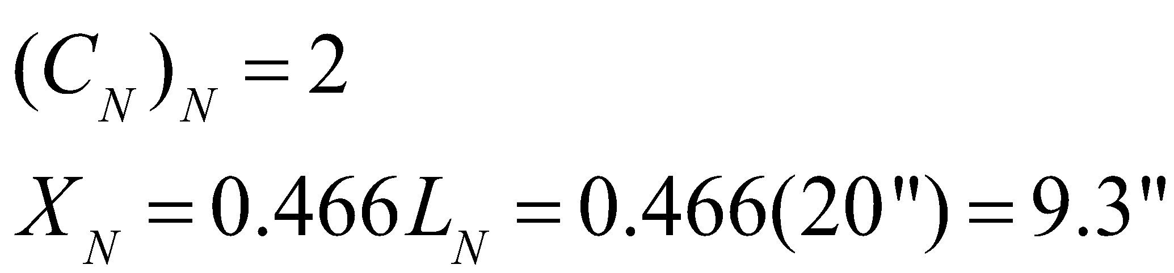 _{(9.32”)}

where LN = 20”, is the length of our nosecone.

For our four-fin rocket:
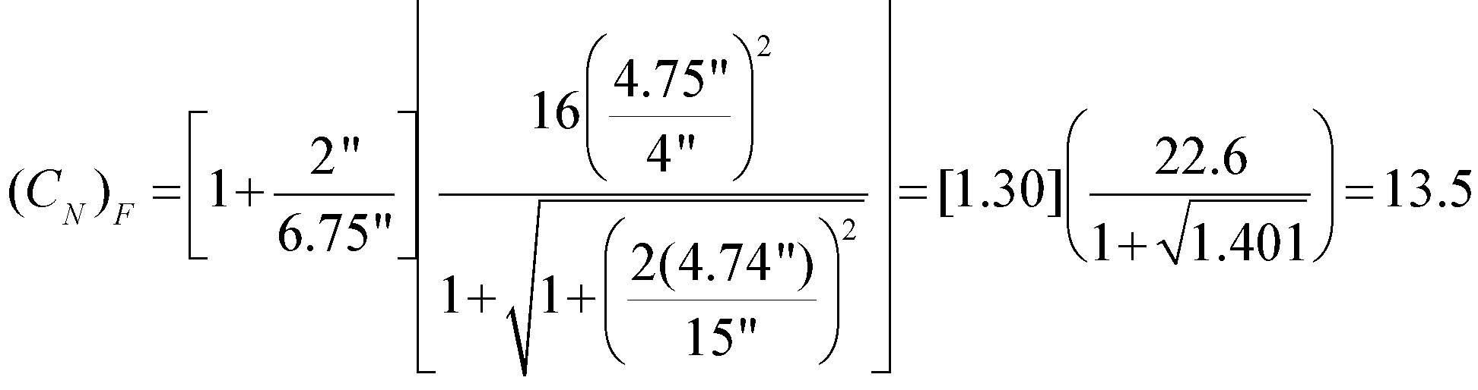

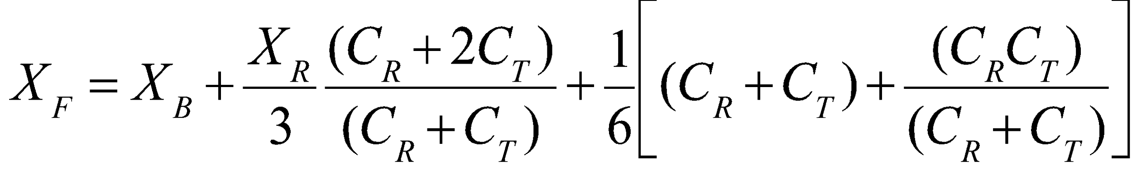
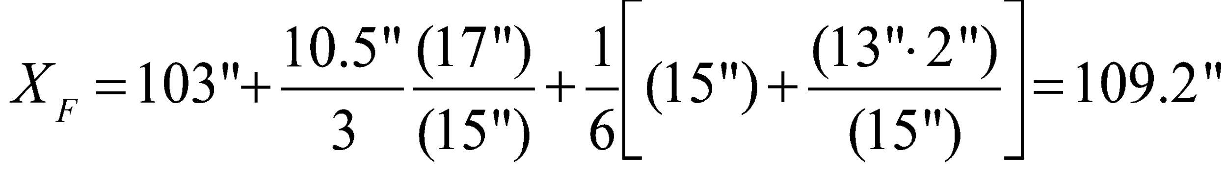

where the radius of the body (R) is 2.0”, the fin semi-span (S ) is 4.75” (which we have taken to equal the length of the mid-chord of fin LF), the body diameter (d) is 4”, the fin root chord (CR) is 13”, the fin tip chord (CT) is 2”, the length of the rocket from nose tip to fin root chord leading edge (XB) is 103”, and the distance between the fin root leading edge and fin tip leading edge parallel to the body (XR) is 10.5”.

With these four results, the distance from the nose tip to the center of pressure can now be determined;
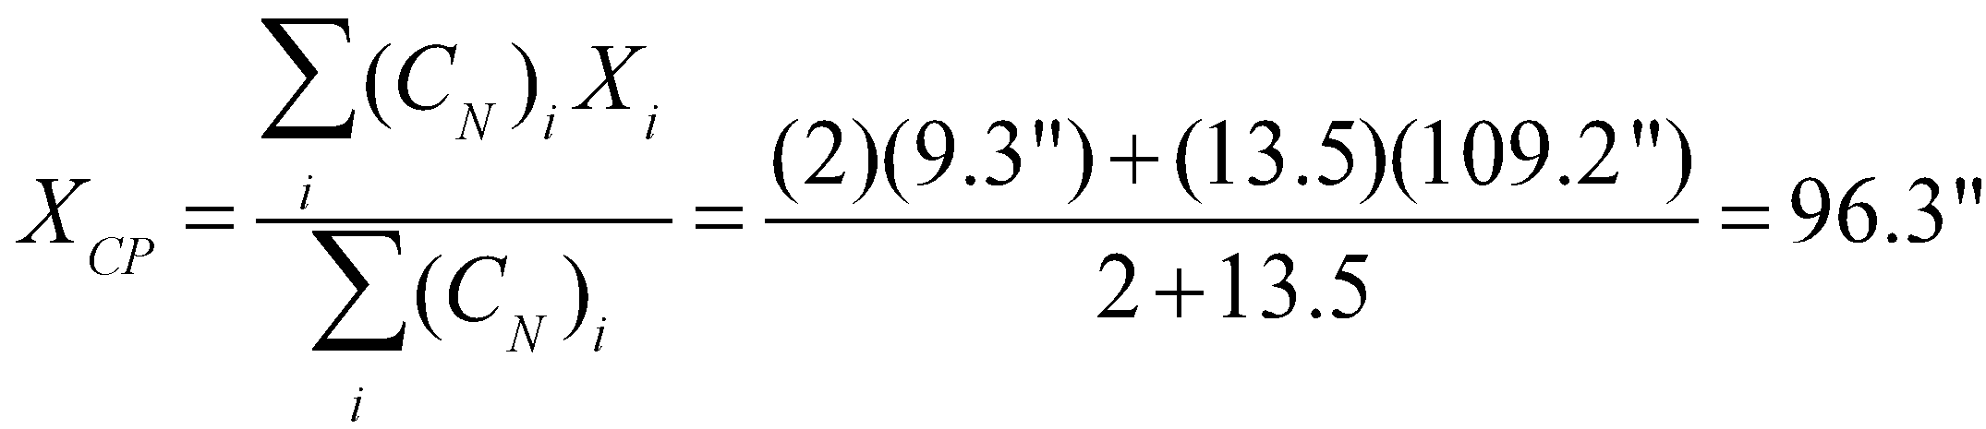

This corresponds very closely to the CP value of 96.22” given us by RocSim.

Determining the Stability Margin

The Stability Margin is defined as the ratio of the difference between the locations of the Center of Gravity and the Center of Pressure to the rocket diameter,

our rocket is over-stable. Whereas being over-stable is not really a stability problem, we must be aware of the surface cross-winds. An overstable rocket, due to a longer lever-arm, is prone to weather-cocking into the wind.

The question of whether our rocket is inherently stable without a payload mass being flown can also be determined, the value for the center of pressure does not change but the center of gravity has a new value of 80.5”. So,

which is also over-stable.

Determination of the Number of Shear pins

In order for the rocket to maintain integrity until the desired moment of separation, two sets of shear pins will be used. A first set (of 2) will keep the booster section in contact with the fore section until the time of the drogue chute deployment, and the second set (of 6) will keep the payload section attached to the fore section until the main chute and payload are deployed. For our rocket, ½”440 Teflon threaded screws will be used as shear pins for two major reasons; These have been flown numerous times for several past projects, are familiar to the team, and have worked well for us. Secondly, these are readily available to us.

In order to determine the proper number of pins, a simple stress test was performed. A bucket was attached to, and suspended below, a spare coupler unit that was held in place to a spare body tube by one of the Teflon screws acting as a shear pin. Mass was placed within the bucket until failure was reached. The total mass suspended was 20.6 kg, or 45.4 lbs. Combining this result with the cross-sectional area that the weight was distributed over the stem of the shear pin (3.2 mm X 2.4 mm), we get a stress limit of 3785 psi for a single shear pin. It should be mentioned that a literature search has listed Tensile Strength for Teflon as 3900 psi. For the rest of our calculations, we shall take a failure force 46 lbs/pin.

Once this maximum force value for a shear pin is determined, several items can then
be determined. The force that the shear pins must overcome to keep the booster attached to the fore section is just the aerodynamic drag force that acts on the booster after burnout and continues till apogee. This drag force, to first order, is just the burned-out mass of the booster section, 4.4 kg or 9.7 lbs. This value is well within the failure limit of one stress pin, but two will give a redundancy that needs to be overcome by the Drogue deployment charge.

The harder value to calculate is the number of pins required to hold the payload section to the fore section while the Drogue chute is being deployed. To begin this, we need to assume a change in the speed of the forward section of the rocket as the deployment is occurring. Since the rocket (theoretically) will not be moving much at apogee, and the maximum drogue chute descent rate is fixed, we can take a change in speed of 25 m/s. This change in speed corresponds to an impulse of 95 Ns, acting on the payload section. As a conservative estimate, we assume a very short deployment time of 0.1 s (really equivalent to a sudden jerk), which yields an inertial force of 950 N. This corresponds to an inertial force of 215 lbs, which must be overcome by a number of shear pins. The number of shear pins needed to do this then works out to be 215 lbs/(46 lbs/pin) ~ 5. Again, we have added an extra pin for surety, and needs to be overcome by the main chute deployment charge.

Determination of the Black Powder for Pyrotechnic Charges

Determining the amount of Black Powder (BP) to deploy a chute, or separate a section of the rocket, is a delicate balancing of pushing hard enough to deploy the unit while not causing permanent damage to the rocket, or turning it into a pyrotechnic display more appropriate for the 4th of July. As it turns out, there is a semi-empirical, linear relationship between the amount of BP to be used and the product of the required ejection force (E_{eject}) and the length (L) of the section that the produced gas must expand into. The relationship is outlined by J.H. Wickman (“How to Make Amateur Rockets” 2nd Edition, section 18.5-6) and is based on several simple assumptions: the tube is instantly pressurized, no heat is lost to the rocket body tube, and the gas acts nearly ideally.

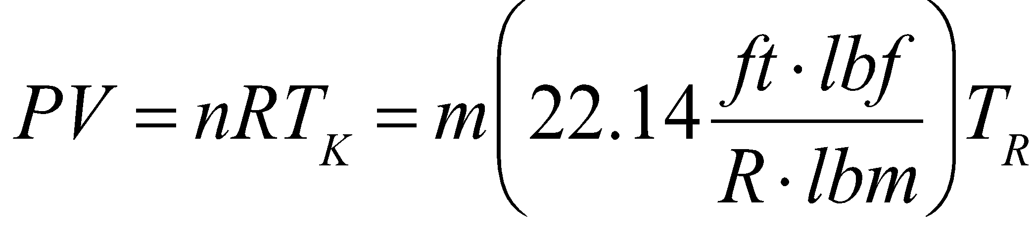

where m is the mass of the gas produced (~the mass of the BP in lbs), P is the gas pressure, V is the volume the gas will occupy, and T_{R} is the Rankine burning temperature of BP (which is 3307 R – the Rankine scale is the Fahrenheit scale that is calibrated to Absolute zero). The expansion volume is A_{cs} L, where A_{CS} is the cross-sectional area of the gas volume, and the pressure is the ratio of the desired ejection force to the cross-sectional area (F_{eject}/A_{CS}). As such,

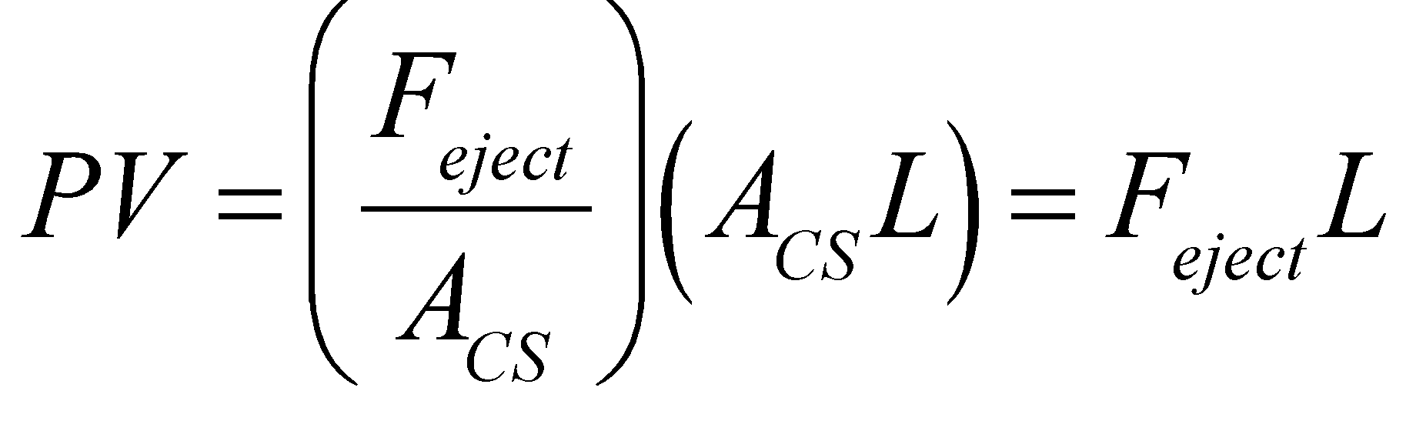

After rearranging,
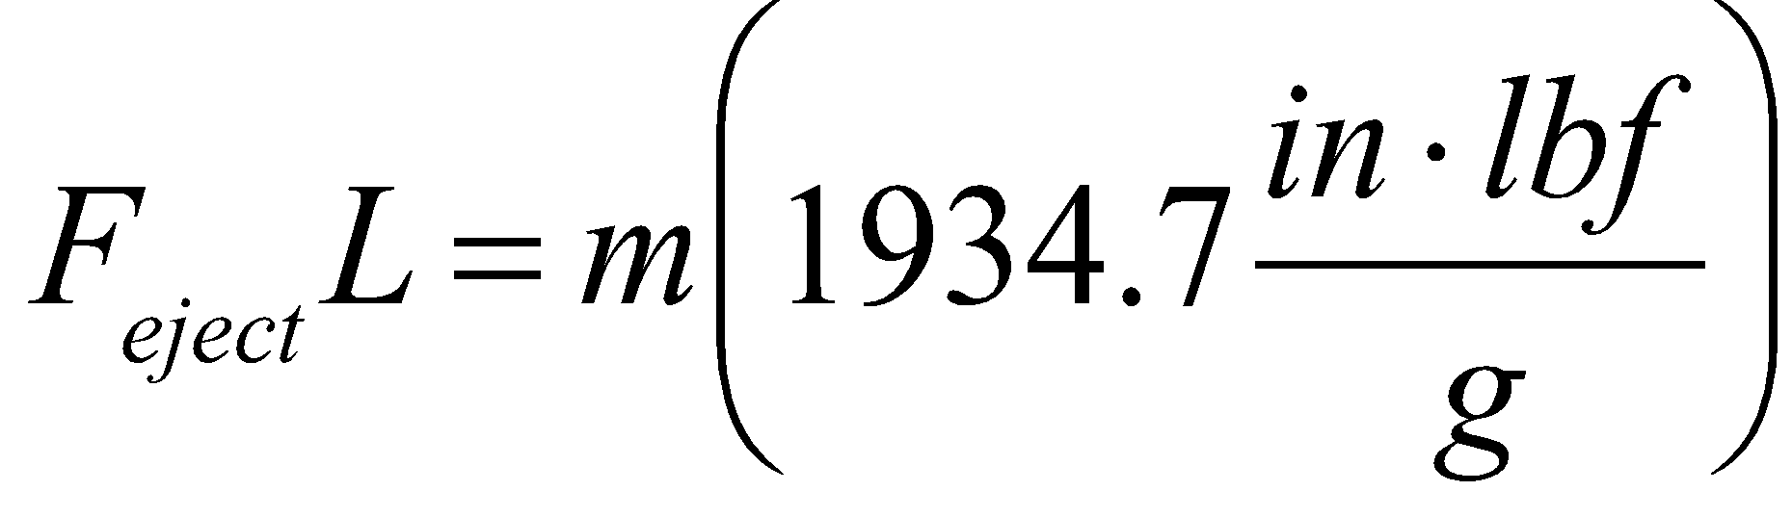

Solving for the mass, and after some experimentation, Wickman found that the addition of a 1.25 g offset was needed. The final semi-empirical relationship is…

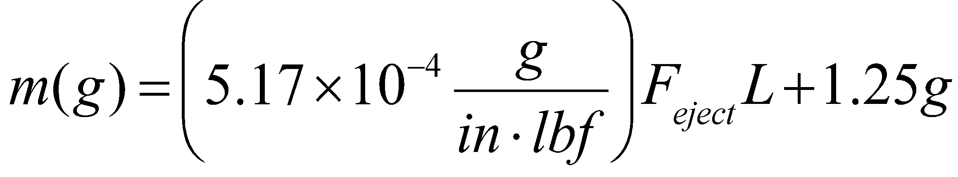

The determination of the ejection force is specific to the unit being deployed and is equal to the sum of the external aerodynamic forces acting on that section rocket (which really can be set to the weight of the part of the rocket) being deployed, the force of friction between the coupler and the booster (assumed to be ~2 lbs), and the force required to overcome the number of shear pins. So, for the drogue deployment this force works out to be 27.3 lbs + 2 lbs + (2 pins)(46 lbs/pin) = 121.3 lbs. Insertion of this, along with a gas expansion length of 19”, into the above expression yields a deployment charge of 2.44 g ~3g. Following the same procedure, the main chute deployment, and separation of the payload section, requires an ejection force of 17.8 lbs + 2 lbs + (6 pins)(46 lbs/pin) = 295.8 lbs. This, and an expansion length of 21.5”, yields a deployment charge of 4.54 g ~ 5g.

Obviously, the inherent assumptions used to come up with these estimates can be questioned. Because deployment of the chutes is of utmost importance to the safety of the team, and anyone else in the vicinity, these values need to be tested. Ground testing of these charges will be performed to confirm that these values do indeed have enough force to separated the pinned units, and adequately deploy the chutes.

Determination of the Chute Sizes

The actual determination of the chutes sizes is a relatively easy process; the weight of the suspended descending unit is set equal to the drag force that the chute must supply at terminal velocity.
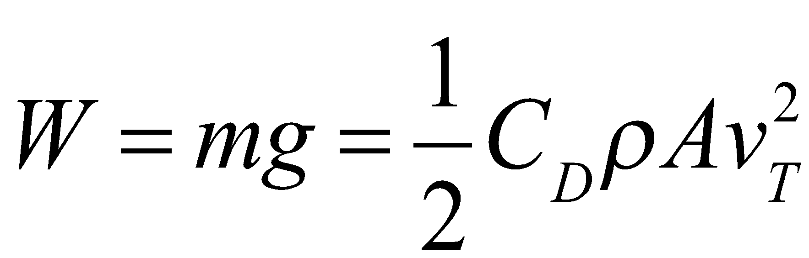

where m is the mass of the descending unit, C_{D} is the drag coefficient (usually taken to be ~0.8), ρ is the density of air (1.27 kg/m³), A is the area of the chute, v_{T} is the terminal velocity of the descending unit. Assuming a circular shape for our chute, and solving for the diameter (D), yields…

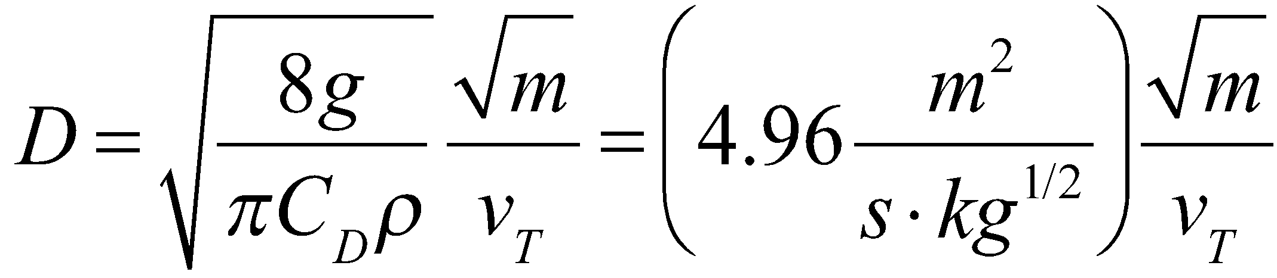

For the drogue chute, m = 13.3 kg and v_{T} = 25 m/s, which yields D = 0.72 m, ~2’ 4”.

Our project will have one phase where the entire rocket will be descending at 25 m/s (~80 ft/s), and the second phase will have two units descending at 7 m/s and 5 m/s. The former is assigned to the payload section, and the latter is for the rest of the rocket and will determine the main chute size. The descending speeds are determined by the fact that no descending unit should have a kinetic energy greater than 75 lb ft (~102 J).
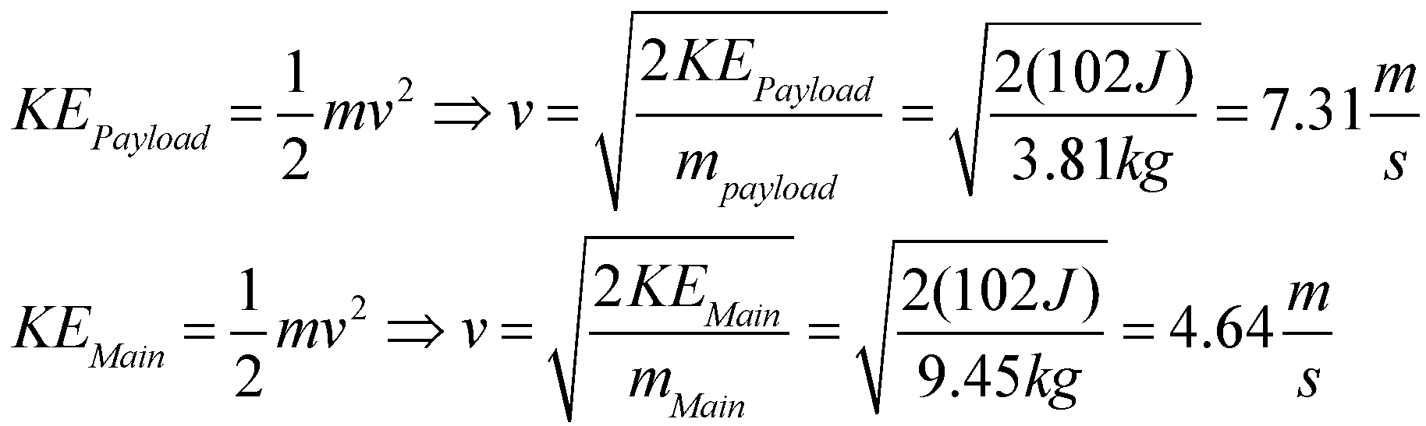
So, for the main chute, m = 9.45 kg and v_{T} = 4.64 m/s, which yields D = 3.3 m ~ 10’8”.
For the payload section, m= 3.81 kg and v_{T} = 7 m/s, yields D = 1.38 m ~ 4’6”

